Module 3: The Psychology & Power of Stories

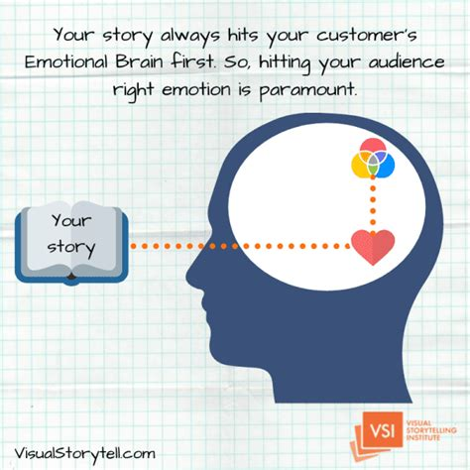
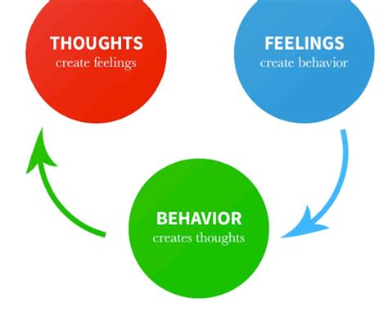
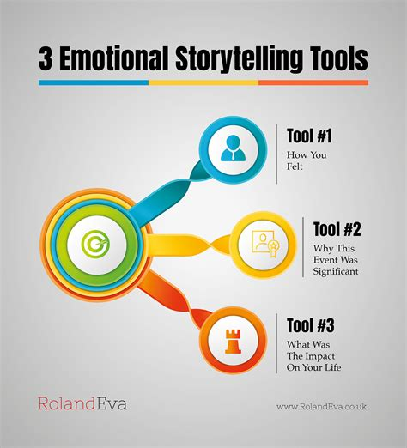
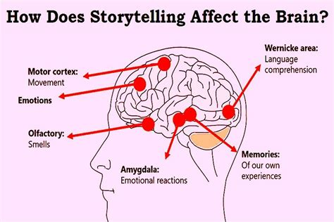
5 images

Module Metadata: The Psychology & Power of Stories (1 Hour)

Short Description
Storytelling is more than just entertainment—it is a fundamental part of human cognition, communication, and culture. Scholars in folklore, psychology, and even business recognize the profound impact of stories on shaping emotions, memory, learning, and social cohesion. As Jonathan Gottschall, author of The Storytelling Animal, states: "We are, as a species, addicted to story. Even when the body goes to sleep, the mind stays up all night, telling itself stories."
Stories influence how we think, feel, and interact with the world. Below are some of the most significant functions of storytelling:

Explore the psychological and cultural impact of storytelling. This module reveals how stories shape emotions, memory, learning, and social cohesion — and how these insights can be harnessed for education, activism, and creative entrepreneurship.

Long Description

Storytelling is embedded in the human psyche. From folklore to neuroscience, stories influence how we think, feel, and connect. This module dives into the cognitive and emotional power of storytelling, examining its role in shaping identity, fostering empathy, and building community. Learners will explore how stories activate the brain, simplify complex ideas, and inspire action — with real-world case studies from Mandela to LEGO. By understanding the psychology behind storytelling, learners will gain tools to craft narratives that educate, unite, and drive entrepreneurial ventures across media, education, and social impact.

Aims
- To explore the psychological and neurological foundations of storytelling.
- To highlight storytelling’s role in emotional development, memory retention, and social cohesion.
- To demonstrate how storytelling can be used in education, activism, and entrepreneurial contexts.

Objectives

By the end of this module, learners will be able to:
- Identify key psychological functions of storytelling, including emotional engagement and memory enhancement.
- Analyze how stories influence learning, empathy, and cultural identity.
- Examine case studies that illustrate storytelling’s power in business, activism, and education.
- Reflect on how storytelling can be used to build brands, campaigns, and community initiatives.

Learning Outcomes

Learners will:
- Demonstrate understanding of storytelling’s cognitive and emotional impact.
- Apply storytelling insights to educational, cultural, and entrepreneurial projects.
- Analyze powerful storytelling moments across history and media.
- Begin to conceptualize storytelling as a strategic tool for influence, innovation, and enterprise.

- Improves conversational skills – Helps individuals express thoughts clearly and engage in meaningful dialogue.
- Enhances listening skills – Encourages active listening and comprehension.
- Develops critical and analytical thinking – Encourages deeper reflection and reasoning.
- Enables problem-solving – Stories present challenges and resolutions, fostering creative thinking.
- Generates morals and values – Many stories teach ethical lessons and societal norms.
- Promotes culture and cultural identity – Preserves traditions and reinforces collective identity.
- Facilitates multiculturalism, social cohesion, and community building – Bridges cultural gaps and fosters unity.
- Educates on difficult topics – Makes complex or sensitive subjects more accessible.
- Simplifies complicated concepts – Uses narrative structures to make abstract ideas relatable.
- Strengthens emotions – Evokes empathy, joy, sadness, and inspiration.

How Storytelling Shapes Emotions and Memory
Stories have a profound neurological impact, engaging multiple brain regions responsible for emotions and memory. Research shows that storytelling activates the limbic system, which processes emotions, and the hippocampus, which aids memory retention2.
- Emotional Connection – Stories trigger the release of oxytocin, the "bonding hormone," fostering empathy and trust.
- Memory Retention – Information presented in a narrative format is more memorable than raw data.
- Neural Coupling – When listening to a story, the brain mirrors the storyteller’s emotions, creating a shared experience.
- Sensory Engagement – Descriptive storytelling activates sensory and motor cortices, making the audience feel immersed in the narrative.
For example, a well-told personal story about overcoming adversity can inspire and emotionally move an audience more than a list of facts.

The Impact of Stories on Learning and Social Cohesion
Storytelling is a powerful educational tool that enhances learning and strengthens social bonds4.
- Learning Enhancement – Stories simplify complex concepts, making them easier to understand and remember.
- Social Connection – Shared narratives create a sense of belonging and unity.
- Empathy Development – Exposure to diverse stories fosters understanding and tolerance.
- Cultural Exchange – Stories from different backgrounds promote multicultural awareness.
- Community Building – Storytelling in group settings strengthens relationships and collective identity.
For instance, collaborative storytelling in classrooms has been shown to improve group interactions and inclusivity among students.

Case Studies of Powerful Storytelling Moments
Throughout history, storytelling has shaped movements, inspired change, and connected people on a deep level7. Here are some notable examples:
- Nelson Mandela’s Story – His personal journey from prisoner to president became a global symbol of resilience and justice.
- The Maasai Olympics – A storytelling-driven initiative that transformed traditional lion-hunting rites into athletic competitions, promoting conservation and gender equality.
- The National Lottery’s 30th Anniversary Campaign – A storytelling-based campaign that humanized winners’ experiences, making the message more relatable.
- LEGO’s Brand Storytelling – The company uses narratives of creativity and imagination to inspire generations.
- The Barbie Flip Phone Campaign – A nostalgic storytelling approach that resonated with audiences by promoting digital detox.

Final Thoughts
Storytelling is a psychological, cultural, and educational force that shapes how we perceive the world. Whether used in education, business, or activism, stories have the power to influence emotions, strengthen memory, foster social cohesion, and inspire action.
Exercise: Identify a story that deeply impacted you—explain why it was memorable.
Assignment: Analyze a popular speech or TED Talk—how does storytelling enhance the message?

